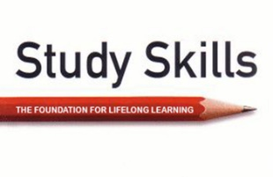

Sully Buttes Middle School
– 6th Grade Study Skills and Social Emotional Learning (Tues & Thurs)
Mrs. Aspelin
www.jaspelin.weebly.com
Lesson plans will be posted to this site.

Study Skills: You are about to learn lifelong skills and strategies that will promote the ability to learn, organize, and recall new information.

Social Emotional Learning:
SEL is the process through which all young people and adults acquire and apply the knowledge, skills, and attitudes to develop healthy identities, manage emotions and achieve personal and collective goals, feel and show empathy for others, establish and maintain supportive relationships, and make responsible and caring decisions. We will be doing lessons once a week on Suite 360 that pertains to SEL. (CASEL, 2022)

Policy for absences and grades

Weekly and daily work will be graded and updated weekly. Please check grades regularly and feel free to ask me any questions that you might have about a particular grade.
If you are absent, you are responsible for obtaining a make-up sheet from the office and getting all teachers to sign it. You will get two school days to complete make-up work for each day absent, after that it will be considered late, put on ICU, and points will be deducted on a per-day-late basis.
Most work will be on Schoology and can be accessed at home.

Late, Incomplete, or missing Daily Work- will be assigned to the ICU List. Please see ICU policy in the handbook for more information on this and assessment retakes.

CLASSROOM RULES AND PROCEDURES
- Treat others in the classroom with respect.
  - This includes their property, their space, and their opinions.
- Follow all the rules as outlined in the student handbook.
- Come to class prepared for the day – Bring all required materials!
- No Cell Phones (Handbook, 2023.)
- Only use iPad when teacher approves it. (NO playing games on iPad’s during lecture time.)
- Most work will be online on Schoology or Suite 360
- If you finish the assigned task early, you will be responsible for finding something to do that does not disrupt others working. READ – bring book to class.
- This is a public library. There may be patrons checking out books while we are having class. You should stay focused on our class and not to interact or disrespect others from trying to use the library. We can talk but need to keep the noise level down.
- Other spaces in the library may be used when working on individual work.

Materials:
- Plan book (Bring to every class, every day!)
- Folder for work
- iPad
- Independent reading book (bring every day to class)
- Headphones (optional)

